Councillor’s Monthly Bulletin – January 2022
from Maurice Cook and Lydia Freeman
(Please circulate electronically and print only when necessary. We should be most grateful for our bulletin to be posted on your websites for the benefit of your residents.)

Welcome to our first Bulletin of 2022 and a Happy New Year to all.

Survey of East Suffolk businesses
We are currently looking at the vitality of our town centres and in order to help understand
and improve town centres, we need views from local businesses.

One important source of data is capturing the ‘business confidence’ and perceptions of traders in town centres across the district. By establishing the trading conditions of town centre businesses, we can focus on issues of concerns and how to improve them.

All town centre businesses are encouraged to complete the short survey by Friday 28 January at https://destinationresearch.typeform.com/towncentres

Beach hut village project to be delayed
Having been granted planning permission in October 2021, the construction of a new beach hut village on Felixstowe’s South Seafront was originally intended to being during the new few weeks. This would enable it to be ready ahead of the summer season. | 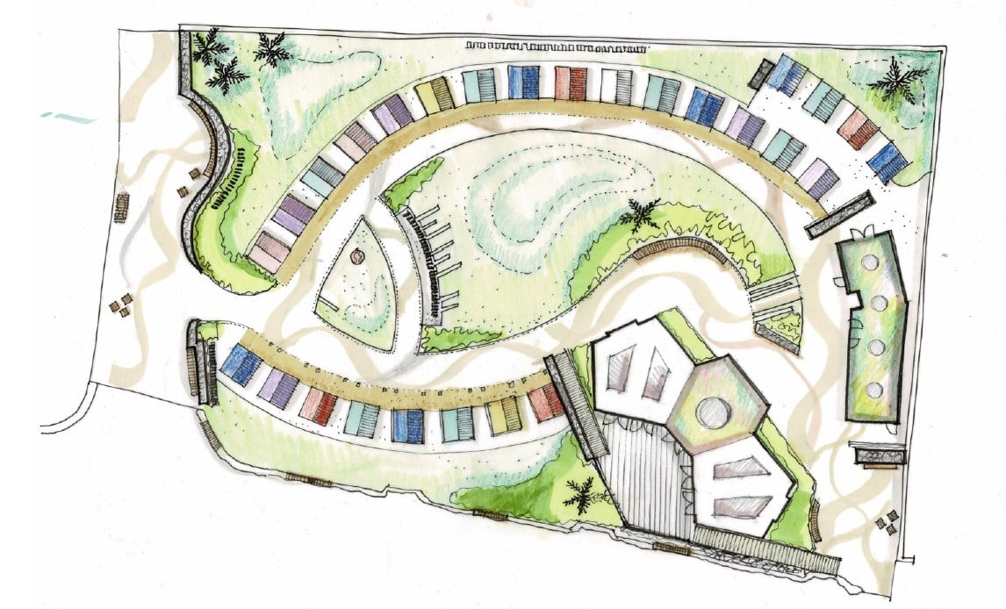
However, with further permissions required before construction could proceed, the project has been delayed by approximately three months. This means that it would not be ready in time for the summer season as hoped and, as a result, we have therefore decided that construction will now get under way in September 2022.

This follows discussions with local businesses, residents and other stakeholders about the likely disruption that construction will cause and a determination not to impact on this year’s summer season and everything the South Seafront has to offer.

Supporting customers to access council services
To ensure residents can continue to access our services in the way that suits them best, our Marina Centre in Lowestoft is open (Tuesdays and Thursdays 10am – 4pm), along with our desks at Woodbridge and Saxmundham Libraries (Wednesdays 10am – 4pm) and at Felixstowe and Leiston Libraries (Fridays 10am – 4pm) – all by appointment only.

The majority of our services are available at www.eastsuffolk.gov.uk and we encourage residents to continue to use these online services wherever possible.

However, anyone with difficulties using these services or who are unable to resolve an issue online, can email or call our Customer Services Team. If still unable to resolve the issue, an appointment can be made for one of our Customer Services locations in person by calling 0333 016 2000.

Residents can also learn how to access our online services and report issues directly, using our new ‘digital receptions’ which are available at the Marina Centre and libraries. Residents should book an appointment and our fully trained Customer Services staff will be available as ‘digital champions’ to help them get online.

Further funding to benefit local communities
The Carlton Colville, Kessingland, Southwold and Surrounding Village Community Partnership initially launched its Small Grant Sceme in December 2020, followed by a second round in May 2021 and a third round in August 2021.

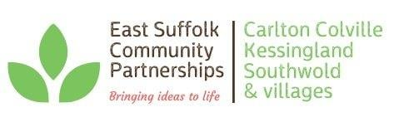 | The Partnership has now confirmed a fourth round will open on 10 January, meaning local voluntary and community groups can once again for much-needed funding.

The scheme is aimed at tackling social isolation and loneliness and improving the services available to young people, two of the priorities identified by the Partnership and may support groups and organisations who will be facing challenges post lockdown.
Funding will be available for projects which addresses these and can include activities that can help individuals, groups and families or benefit the wider community, either as a one off or as a series of activities/events, purchasing equipment to support community activity and targeted projects which addresses specific needs linked to the priorities set by the Partnership.

The scheme, which will be open for applications from 10 January until 7 February 2022, will offer grants of up to £1,500 and more details, including criteria and how to apply, will be available soon at www.eastsuffolk.gov.uk/community/community-partnerships/community-partnership-small-grant-schemes/

Southwold residents to vote on Neighbourhood Plan
Residents in Southwold will be asked whether a Neighbourhood Plan for the town should be used by the Council for future planning applications.

The Southwold Neighbourhood Plan was developed by Southwold Town Council following extensive consultation with the local community and sets out its vision for development to 2036.

Following a six-week public consultation last year, an independent examination has now been completed which found the plan meets all legal requirements, subject to some amendments.

As a result, we have concluded that the Plan should proceed to a referendum incorporating the recommended amendments suggested by the examiner. The referendum will take place on Thursday 3 February and will ask residents to vote on whether we should use the Neighbourhood Plan for Southwold to help determine planning applications in the neighbourhood area.

Details about the referendum and how to vote will be published soon.

For more details about the Southwold Neighbourhood Plan, including the examiner’s report and our statement, go to www.eastsuffolk.gov.uk/planning/neighbourhood-planning/neighbourhood-plans-in-the-area/southwold-neighbourhood-area/

Surveys and consultations
We are currently running one consultation and, as always we want to encourage participation as feedback from people in East Suffolk is invaluable and helps us ensure we’re making the right decisions for our communities.

- The draft East Suffolk Cycling and Walking Strategy
Consultation on draft document which provides a district-wide shortlist of cycling and walking infrastructure opportunities. The strategy aims to encourage greater use of sustainable forms of transport, reduce contributions to climate change, support the growth of the tourism industry, and to improve the health and wellbeing of residents by ensuring more trips to work, school, leisure, day-to-day errands, or public transport hubs, such as train stations or park and ride sites, are accessible by bike or on foot. Once adopted, this strategy will replace the Waveney Cycle Strategy (2016) and will cover the whole of the district. People can have their say on the consultation until 10 January at https://storymaps.arcgis.com/stories/cbc57e4a9cc24eeea7d174fb34b1bf0e

Diary dates

- 10th January at 2pm – Kesgrave, Rushmere St Andrew, Matlesham, Carlford and Fynn Valley Community Partnership (Zoom)
- 10th January at 6pm – Beccles, Bungay, Halesworth and villages Community Partnership (Zoom)
- 11th January at 2pm – Planning Committee North (Riverside)
- 13th January at 6pm – Framlingham, Wickham Market and villages Community Partnership (Zoom)
- 14th January at 10am – Licensing Sub-Committee (ESH)
- 20th January at 6.30pm – Scrutiny (ESH)
- 25th January at 2pm – Planning Committee South (ESH)
- 26th January at 6.30pm – Full Council (ESH)
- 27th January at 4pm – Southwold Harbour Management Committee (TBC)
- 1st February at 6.30pm – Cabinet (ESH)

