SUFFOLK COUNTY COUNCILLOR’S SPECIAL REPORT – JULY 2020
Councillor Stephen Burroughes

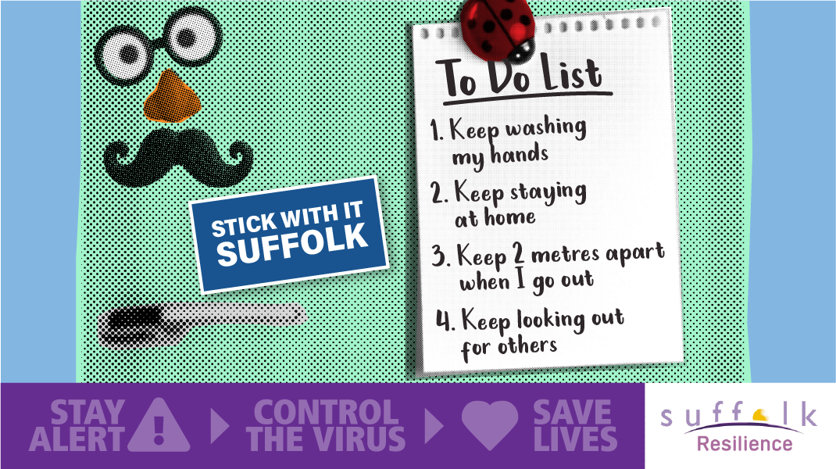

COVID-19 related news
- New plan sets out how Suffolk will prevent & respond to COVID-19 outbreak
A plan which sets out how Suffolk would prevent and respond to a localised outbreak of COVID-19 was published on 30 June. Suffolk’s Local Outbreak Control Plan will be triggered where there are suspected or confirmed COVID-19 outbreaks in any setting or community within the county. The plan, a requirement of Government of all local authorities, outlines measures to prevent, manage, and contain outbreaks of Coronavirus and protect the public’s health. It builds on existing relationships and processes in place with partner agencies across Suffolk. The plan outlines how complex cases will be managed in more than 30 high-risk places, locations, and communities, particularly care homes and schools. It also outlines local testing capacity, use of data to identify and proactively manage outbreaks, and contact tracing in complex settings. An outbreak is defined when there are two or more cases in high-risk settings, or a greater than expected occurrence of COVID-19 compared with the usual level for a particular place and time. Delivery of the Local Outbreak Control Plan will be co-ordinated by the Suffolk COVID-19 Coordination Centre. All information (including outbreak notifications) and national guidance will be received here, which enables a co-ordinated response and allows tasks to be allocated to the most appropriate partners. Suffolk has received £2.79million from a £300million Government fund to support delivery of the Local Outbreak Control Plan.
- Suffolk’s resilience partners continue to provide PPE equipment
As Suffolk’s response to the Covid-19 pandemic enters its fourth month, the team set up in March to source and distribute personal protective equipment (PPE) to support service providers across the county continues to operate from Suffolk County Council’s offices in Ipswich. To date, this PPE ‘cell’ of the Suffolk Resilience Forum (SRF) has distributed over 2.3 million items of PPE across Suffolk. Over 1.9 million of these items have been distributed for use in the care sector to support some of Suffolk’s most vulnerable residents. This equipment is directly supporting a range of staff every day, providing them with the masks, gloves and other disposable protective items needed to ensure safe working and effective infection control in care settings, social care, special schools, emergency services, and health organisations. As service providers increase contact with residents and reopen, or plan for buildings to reopen in weeks to come, Suffolk’s PPE team will continue to purchase and distribute equipment where there is a shortfall in supply, or where organisations identify an urgent need.
- Temporary relaxation of concessionary travel arrangements in Suffolk to end
As more people return to work, public transport operators face the challenge of meeting this extra demand and ensuring adherence to Government guidance. Passenger numbers are highest at the beginning and end of the day, so people who need to make essential journey for shopping, care or health reasons are being encouraged to travel after 9.30am when buses are currently quieter. Suffolk County Council and bus operators in the county agreed to end the temporary relaxation of concessionary travel rules from Monday 6 July 2020. The relaxation was introduced across Suffolk in late March and allowed those with concessionary passes to travel on buses for free before 9:30am. The aim was to provide more flexibility for older people, and those with disabilities, to visit supermarkets during the lockdown. From Monday 6th July concessionary bus passes in Suffolk were are only valid Monday to Fridays 9.30am to 11pm, and all day on Saturdays, Sundays and Bank Holidays. Also, all passengers are now required to wear a face covering on public transport. For more information about concessionary travel in Suffolk, visit suffolkonboard.com.
An alternative travel option for elderly and vulnerable passengers is the county’s Connecting Communities demand responsive services, which operate Monday to Friday 7am to 7pm. Further details can be found at communities.suffolkonboard.com or by calling 0345 606 6171.
- Looking after the vulnerable is top priority
Special Article by Cllr Beccy Hopfensperger, Cabinet Member for Adult Care. Published 23 June 2020.
Nationally the focus of Covid-19 within the care sector has been on care homes. In Suffolk, we recognise that the experience is the same in all care settings, including extra care housing and supported housing, although the prevalence has not been as great. Care settings have been on the frontline in terms of our local response to Covid-19. News of cases, the need for testing, and sadly people passing away as a result of this virus, has been widely reported. I want to share what has been happening within homes to protect residents and give an update on the support the county council is continuing to provide care homes as they face this challenge.
While we are seeing a gradual decrease in the number of cases within Suffolk’s care homes, and the number of deaths due to Covid-19 appear to be reducing, providers are still in the response phase of this pandemic.
Suffolk’s care homes continue to care for residents with the utmost professionalism and kindness. They are following national guidance regarding social distancing, hygiene standards and the correct use of personal protective equipment (PPE). Testing is available for all care homes - for the entire home, including staff and residents who are not displaying any symptoms. Ahead of a national testing site being available, we started testing residents in care homes. Since testing began in mid-April, over 2,300 people have been tested across all care settings and testing continues. With more testing taking place, infection control and prevention measures can be more effective. The county council, with its health partners, continues to have daily contact with care homes to support them and respond to their needs and concerns. This support has included help to source agency staff where there is staff absence, obtaining PPE, a dedicated infection prevention and control enquiry line, and a package of financial support. While providers are responsible for sourcing their own supply of PPE and financial support has been provided to help meet the additional costs, the Suffolk Resilience Forum has supplied care providers with 1.7 million items of emergency PPE when they have encountered difficulty in sourcing their own supply.
The number of people who have died in care homes in Suffolk due to Covid-19 is decreasing on a weekly basis. However, this doesn’t take away from the fact that people have died because of this virus. It is a tragedy that families are losing their much-loved relatives and friends to this virus, and my deepest sympathies and condolences are with those who are grieving during this most difficult time.
In Suffolk, we are continuing to see a higher percentage of Covid-19 related deaths within care homes compared to some other areas. The reasons for this are complex, but factors we think are contributing to this are more people choosing to die in their usual place of residence and the high number of nursing beds that we have within care homes. These provide care for people with complex care needs who may be approaching the end of their life, and I would like to assure people that we have very good practices for providing end of life care in Suffolk. Dying within a care home setting often reflects a person’s wish to remain in their usual place of residence, in comfortable surroundings, with people around them who are familiar, as opposed to being in an unfamiliar hospital setting.
Although we no longer have any council-owned care homes in Suffolk, they are all privately owned and run, the county council still considers looking after the most vulnerable to be its top priority. The council is standing shoulder to shoulder with our care providers as we continue to face this crisis, and I want to take one final moment to praise their monumental efforts and their continued dedication and professionalism. The kindness and warmth that they show our most vulnerable each day, despite the pressures they face, is deeply moving. I would ask people to please do what they can to protect our most vulnerable by continuing to follow government guidance around social distancing and hygiene to reduce the spread of the virus in our communities. Thank you for doing your bit and, please, Stick With It Suffolk.
- Improving Suffolk’s wellbeing & mental health with a simple ‘thank you’
A new, colourful way for people across Suffolk to show their appreciation for others, is underway in Suffolk.
Suffolk Says Thanks recognises the small acts of kindness taking place across the county in response to the coronavirus pandemic. The initiative was launched on 4 June by the Suffolk Resilience Forum, which has a specific group tasked with looking at emotional wellbeing in the community related to the pandemic.
As a direct result of the current situation, people may be experiencing mental health issues, or their emotional wellbeing may be affected. To help with this, the simple act of saying ‘thank you’ is known to have a positive effect on both the person giving thanks, as well as the person receiving it. Posters, cards and other colourful materials can be downloaded from www.suffolksaysthanks.com to provide inspiration for saying thank you in different ways. People are invited to share their messages with others, through the website and on social media, using the hashtag #suffolksaysthanks.
If you are experiencing something that makes you feel unsafe, distressed, or worried about your mental health you can call the FirstResponse service on 0808 196 3494. This phoneline is provided by Norfolk and Suffolk NHS Foundation Trust, and is available 24 hours a day, seven days a week. It provides immediate advice, support and signposting.
Other news
- Joint statement from Sizewell C Joint Local Authorities Group – acceptance of DCO
In a joint statement, published on 24 June, East Suffolk Council and Suffolk County Council outlined that, whilst EDF Energy has formally met the legal requirements for consultation on the Sizewell C proposals, they still have serious concerns about EDF Energy’s consultations to date and its compliance with the Government’s guidance and advice on the pre-application process. The Councils were asked by the Government’s Planning Inspectorate to provide their views on the adequacy of EDF Energy’s consultation so far. In their ‘Adequacy of Consultation Response’, the Councils conclude that EDF Energy has complied with the legal requirements of the Planning Act 2008. However, the lack of a comprehensive set of documents up to this point has compromised the engagement that has taken place, and the Councils do not feel they have been able to complete their pre-application work with the Applicant (EDF Energy) to the extent set out by the Planning Act 2008. In their response, the Councils refer to several statutory consultees and many Town and Parish Councils having raised similar concerns about the level and quality of information that has been made available throughout the consultation exercises.
Given the ongoing lockdown restrictions relating to Covid-19, the councils strongly believe EDF Energy should carefully consider how and when the engagement period on the Development Control Order submission documents should take place, to ensure that all of the community can have their say.
The Adequacy of Consultation Response document, submitted by East Suffolk Council and Suffolk County Council, can be viewed in full alongside other related correspondence by visiting eastsuffolk.gov.uk
- First business benefits from council’s free solar panel scheme
A Lowestoft-based charity is the first organisation to benefit from free solar panels, as part of Suffolk County Council’s Renewable Energy Fund. Nirvana Health and Fitness, on Pinbush Road in Lowestoft, is now hosting a 70kWp solar panel installation and is benefitting from zero-carbon electricity. The council’s £400,000 Renewable Energy Fund is open to eligible businesses looking to reduce their energy costs and carbon footprint through solar power. Successful applicants will have solar panels supplied and installed for free.
Once the panels are installed, the business is sold electricity at a better rate than their existing tariff, so they will see immediate savings. The Fund itself benefits from income generated by the sale of the solar-generated electricity. This means money goes back into the pot, allowing more solar panel applications to be considered by the Fund and installed across Suffolk. The fund complements the council’s and the Suffolk Climate Change Partnership’s other established projects, which are supporting the county’s ambition to be carbon neutral by 2030. For example, Business Energy Efficiency Anglia and the Carbon Charter have been helping local businesses to reduce their carbon emissions for a number of years. In further support of local business, the solar panel installation at Nirvana Health and Fitness has been carried out by Ivy Solar, a Woodbridge-based solar PV specialist. Businesses with a relatively high daytime energy demand and large roofspace, and who are interested in applying to the Renewable Energy Fund, can contact Sarah Gill at Groundwork Suffolk sarah.gill@groundwork.org.uk or call 07720 098980.

For further information from my report or questions please contact me at: stephen.burroughes@suffolk.gov.uk

Cllr Stephen Burroughes
County Councillor for the Framlingham Division
Suffolk County Council
Twitter @CllrStephenB

