Councillor’s Monthly Bulletin – November 2021
from Maurice Cook and Lydia Freeman
(Please circulate electronically and print only when necessary. We should be most grateful for our bulletin to be posted on your websites for the benefit of your residents.)

Ward News
Solar Farm gets approval:
The proposed Solar Farm development across the Parishes of Parham, Great Glemham and Marlesford has received approval by East Suffolk Strategic Planning Committee and will now go ahead. When completed, the project will produce enough renewable energy to service over 16,500 homes and will save 11,000 tonnes of carbon each year. Thanks to the hard work and diligence of the three Parish Councils, significant financial benefits for each community have been agreed for the 40 year life of the project. In addition to making a massive contribution to the Councils environmental aspiration to become carbon neutral by 2030, the business rates receivable will alleviate the pressure on Council Tax increases which will benefit every council tax-payer in the district.

Community Partnership to further Support Katch bus service:
At the recent Community Partnership Board visioning event, with the Chairs and Vice Chairs of the eight Ward based Community Partnerships, a sum of £10,000 was allocated for market research with a view to expanding the service. The Katch buses, which currently run between Framlingham and Wickham Market rail station at Campsea Ashe was supported with funding of £40,000 from the Partnership Board and a further £3,000 from the Framlingham and Wickham Community Partnership. Usage of the service to date has been very encouraging and it is hoped that the service can now be expanded to cover a wider area.

Funding for local projects:
One of the pleasing aspects of a Councillor’s role is the making of grants from our Enabling
Communities Budgets to our communities. Here are two examples:
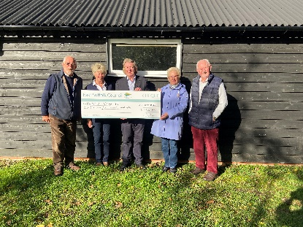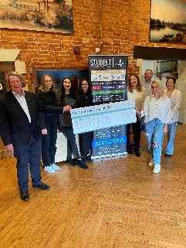
Both Framlinghm Ward Councillors pooled their resources to give £3,000 towards the new storage shed at Kettleburgh Village Hall and £7,500 to support the Mental Health and Wellbeing work of Student Life in Schools and Colleges I Framlingham and beyond.
Whilst, with applications being processed, our budgets for this year are now exhausted, we welcome applications for community based projects in 2022.

District News:
East Suffolk magazine – out now and online!
The latest East Suffolk Magazine - with news and a wide range of information about Council projects, activities and services - is out now.

Produced by the Communications & Marketing team, with contributions from colleagues around the council, it is delivered to every household in the district, twice a year.

You can also read it online at https://www.eastsuffolk.gov.uk/assets/Your-Council/East-Suffolk-Magazine/011-East-Suffolk-Magazine-October-2021.pdf
This edition is not only packed with information, it also contains a survey which anyone who lives or works in East Suffolk is welcome and encouraged to complete. Turn to page 8 for the details or go to www.eastsuffolk.gov.uk/survey.

Culture still the focus in East Suffolk
Our joint bid with Great Yarmouth did not make the longlist for the UK City of Culture 2025 competition. Whilst this is obviously disappointing news, our ambition to shine a light on the wealth of amazing arts and cultural groups and activities in East Suffolk firmly remains.

Our bid has brought people together to talk about the potential of the area and we fully intend to keep that momentum going. The key focus for our joint bid was to offer and promote cultural activities which our communities could get involved with and we will continue to do that wherever possible.

Free event focuses on eco-friendly agriculture
A free online event is taking place next month to explore examples of eco-friendly agriculture in East Suffolk and how others can follow. Titled ‘Farming Today, Fit for Tomorrow’, attendees can learn more about sustainable farming and how we can all help to fight climate change by thinking about how our food is grown.

Organised by the East Suffolk Greenprint Forum, the event will include guest speakers from Suffolk Farming & Wildlife Advisory Group, Oak Tree Community Farm, Maple Farm Kelsale, Peach and Pippin, Wakelyns Agroforestry and Fobbing Farm.

The event is taking place on Friday 19 November at 2pm – 4pm on Zoom and is open to everyone, however, registration is required at https://my.eastsuffolk.gov.uk/service/Greenprint_Forum_event_registration

Bringing empty properties back into use
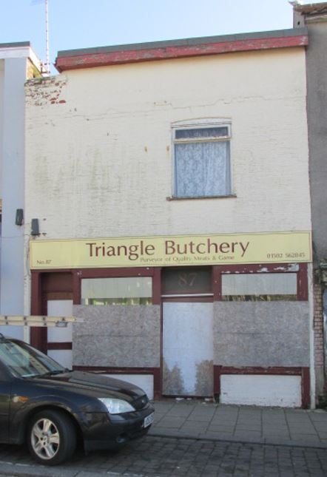 | We’re continuing work to reduce the number of long-term empty properties in East Suffolk as they are a wasted resource, often becoming a target for vandalism, arson, squatters, fly-tipping and other criminal behaviour.  As part of this, we review properties which Council Tax data reveals have stood empty for more than 6 months on an annual basis. Properties which have been empty for more than 2 years but would provide good quality housing that would benefit the community, are priorities during these reviews.  The last review, which was carried out in October 2021,
showed that the number of long-term empty properties in East Suffolk has fallen dramatically over the past 12 months, with a 23% decline in properties standing empty for more than 2 years and a 50% decline in properties standing empty for more than 6 months.

Some long-term empty properties may become part of our housing stock to provide much-needed affordable housing, whilst also address regeneration, such as 87 The High Street in Lowestoft which stood empty within the Heritage Action Zone, in a very poor condition, for more than 6 years. We purchased the property and plans are now being prepared to convert the whole building into flats which may be retained to provide homes for council tenants.

We will continue to work with, and support, owners to help them return long-term empty properties to a positive use, providing much-needed good quality housing in East Suffolk.

More information on what help is available if you own a long-term empty property and how to report a property is available at www.eastsuffolk.gov.uk/housing/empty-properties/

New beach village gets the go ahead
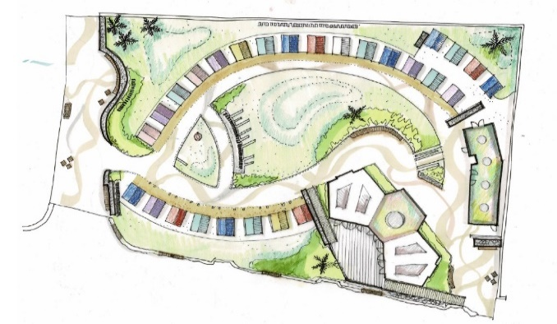 | As part of our ongoing investment in Felixstowe’s South Seafront, a new beach village has been given the go ahead to improve the beach hut experience for locals and visitors.  The beach village will include 5 accessible, purpose-built pods, 27 traditional huts and a new public convenience block with Changing
facilities.

The existing trim trail has been moved to Langer Park and the current volleyball site will be re-landscaped and made into an activity park. As part of this, new outdoor gym equipment will be installed, along with additional facilities, including concrete table tennis tables, a climbing wall, petanque pistes, accessible picnic benches, chess tables and outdoor space for workouts. Furthermore, a new name for the site has now been decided after we ran a survey in which local people were asked to vote for their favourite names from a top five. Nearby 500 people took part and with over 30% of the votes, the new site will be named the Seashore Village.

Construction is expected to begin in early 2022 with completion scheduled for later in the year.
Local communities to benefit from further funding
Two Community Partnerships have announced a further round of their Small Grant Schemes, enabling community and voluntary groups to apply for much-needed funding:

The Framlingham, Wickham Market and Villages Community Partnership has opened for its second round of funding for projects that help develop opportunities for young people and reduce social isolation and/or loneliness. The scheme is open until 3 December 2021, offering grants between £250 and £1,000.

The Melton, Woodbridge and Deben Peninsula Community Partnership has opened for its third round of funding for projects that help improve opportunities for young people and community village hubs. The scheme is open until 1 January 2022, offering grants between £250 and £2,500.

Full details about eligibility criteria and how to apply can be found at www.eastsuffolk.gov.uk/community/community-partnerships/community-partnership-small-grant-schemes/

Lowestoft resident charged over nuisance noise offences
A Lowestoft man has been fined over £2,000 for continuing to play loud music, despite being given a notice to stop.
At a hearing at Suffolk Magistrates’ Court on Friday 15 October, David Learmonth from Burnham Way in Lowestoft was found guilty of breaching Section 80(1) of the Environmental Protection Act 1990 and failing to comply with an abatement notice served under Section 80(1) of the Environmental Protection Act 1990, contrary to Sections 80(4) and 80(5) of the Environmental Protection Act 1990.
Mr Learmonth attended the court but was denied attendance to the hearing due to threatening behaviour towards staff earlier in the day. Permission was granted to proceed in his absence.
The court fined Mr Learmonth a total of £2,040 for the offences, comprising £500 for two charges of breaching the abatement notice, £940 in costs and £100 for the victim surcharge.
Under the Noise Act 1996, the court also ordered the forfeiture of Mr Learmonth's sound equipment, including a bass box, CDs, a sound bar and several sets of speakers.

All aboard the Bungay Shoppa
Delivered by Bungay Events and Business Association and Bact community transport, the new service will connect those isolated and without transport in Bungay’s neighbouring villages to Bungay on market days.  The Bungay SHoppa will serve stops in Wainford, Shipmeadow, Barsham, Ilketshall St. Andrew, Ilketshall St. John, | 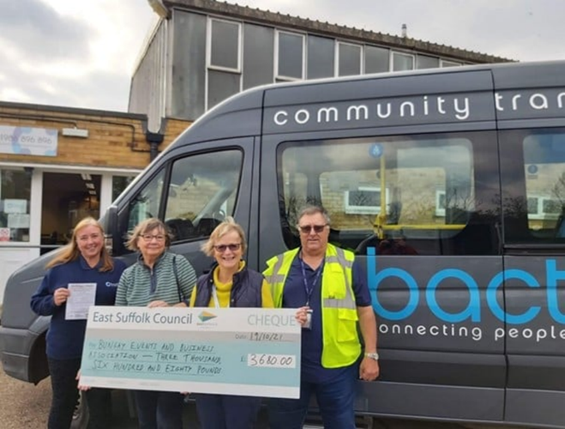
Ilketshall St. Lawrence, Ilketshall St. Margaret, South Elmham St. Peter, South Elmham St. Michael, All Saints, Rumburgh, Homersfield and Flixton.
The service will take place on Thursdays (market days) until February and will also run on the Sunday Street Market days that fall during this time.
The project has received funding from the Beccles, Bungay, Halesworth and villages Community Partnership as well as funding from Cllr Judy Cloke’s Enabling Communities Budget.
View the timetable at https://bungay-suffolk.co.uk/bungay-shoppa-timetable/

Sizewell C Examination: Our response
As part of a six-month Planning Inspectorate examination of the proposals for a new nuclear power plant at Sizewell, we welcome a range of important revisions to the scheme and a multi-million pound financial package for investment back into local communities.

Read our full response here: www.eastsuffolk.gov.uk/news/sizewell-c-examination-east-suffolk-council-response/

Funding boost for innovative new youth project
Last week cabinet agreed to allocate £101,650 for a two-year pilot project which aims to support young people in rural parts of East Suffolk as they face ongoing challenges
from the pandemic.

Delivered by Community Action Suffolk, the Rural Youth Support Project will initially focus on the four most rural Community Partnership areas in East Suffolk, which are within the Beccles, Bungay, Halesworth and villages Community Partnership, the Carlton Colville, Kessingland and villages Community Partnership, the Framlingham, Wickham Market and villages Community Partnership and Melton, Woodbridge and Deben Peninsula Community Partnership.

The aim of the project is to provide support tailored to each community, which will be based on engagement with its young people about their needs. This could include providing more social opportunities with a youth café or youth club, supporting a healthier lifestyle with activity sessions or making services more accessible with carpools.

COP26 open letter
Cllr James Mallinder, Cllr Louise Gooch and Cllr Caroline Topping have penned an open letter to residents in a response to COP26. I have attached the letter to this email as you might find it helpful.

Surveys and consultations
We are currently running a couple of surveys and consultations and, as always we want to encourage participation as feedback from people in East Suffolk is invaluable and helps us ensure we’re making the right decisions for our communities.

- East Suffolk survey
We’re asking people who live and work in East Suffolk to take part in a short service to help us shape East Suffolk. After such a difficult period, we would like to know what they think, what matters most to them and where we should be spending our money. The survey closes on 29 November: https://eu.surveymonkey.com/r/EastSuffolkSurvey

- The Affordable Housing Supplementary Planning Document
Consultation on draft document which will provide guidance on the implementation of our affordable housing planning policies. People are able to comment until 13 December at https://eastsuffolk.inconsult.uk/ESAFFHSGDRAFT/consultationHome

- The Sustainable Construction Supplementary Planning Document
Consultation on draft document which will provide guidance on our planning policies on sustainable construction, including guidance on a range of topics relating to the construction of environmentally sustainable buildings. People have until 13 December to comment: https://eastsuffolk.inconsult.uk/SUSCONSPDDRAFT/consultationHome

- The draft East Suffolk Cycling and Walking Strategy
Consultation on draft document which provides a district-wide shortlist of cycling and walking infrastructure opportunities. The strategy aims to encourage greater use of sustainable forms of transport, reduce contributions to climate change, support the growth of the tourism industry, and to improve the health and wellbeing of residents by ensuring more trips to work, school, leisure, day-to-day errands, or public transport hubs, such as train stations or park and ride sites, are accessible by bike or on foot. Once adopted, this strategy will replace the Waveney Cycle Strategy (2016) and will cover the whole of the district. People can have their say on the consultation until 10 January at https://storymaps.arcgis.com/stories/cbc57e4a9cc24eeea7d174fb34b1bf0e

- Proposed extension to Beccles Cemetery
People are invited to have their say on proposals to extend Beccles Cemetery. The proposed extension will allow for traditional burial and cremation plots, as well as meadow burial plots where grass will be left to grow longer in the summer. Green burials will also be available. People can view the documents at https://www.eastsuffolk.gov.uk/assets/Community/Cemeteries/Beccles-Cemetery-extension-consultation.pdf and email comments to leisure@eastsuffolk.gov.uk by 31 December 2021.

That’s all for this month!

